Create a simple cloud web application for student counselling system using any Cloud Service Provider to demonstrate SaaS with the fields of student name, age, address, phone, subjects studied, Year of passing, percentage of marks, domain interest, etc.

Step1: Implementing a simple cloud web application for student counselling system using cloud services.

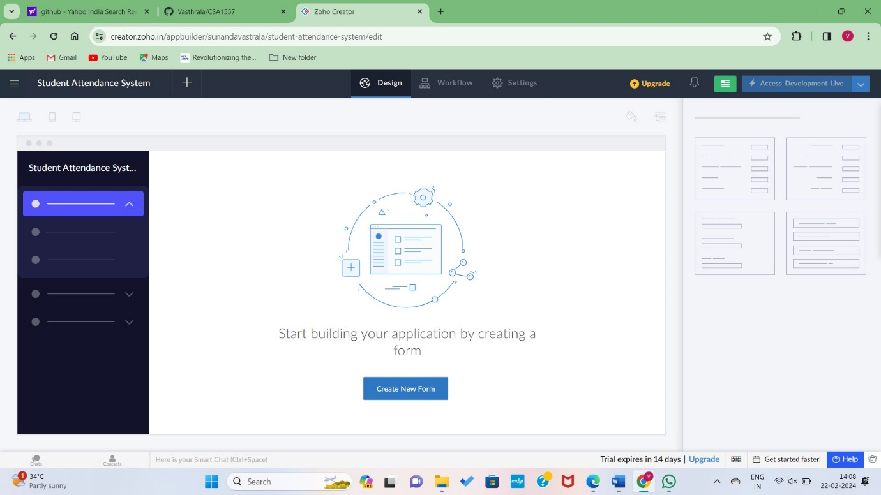

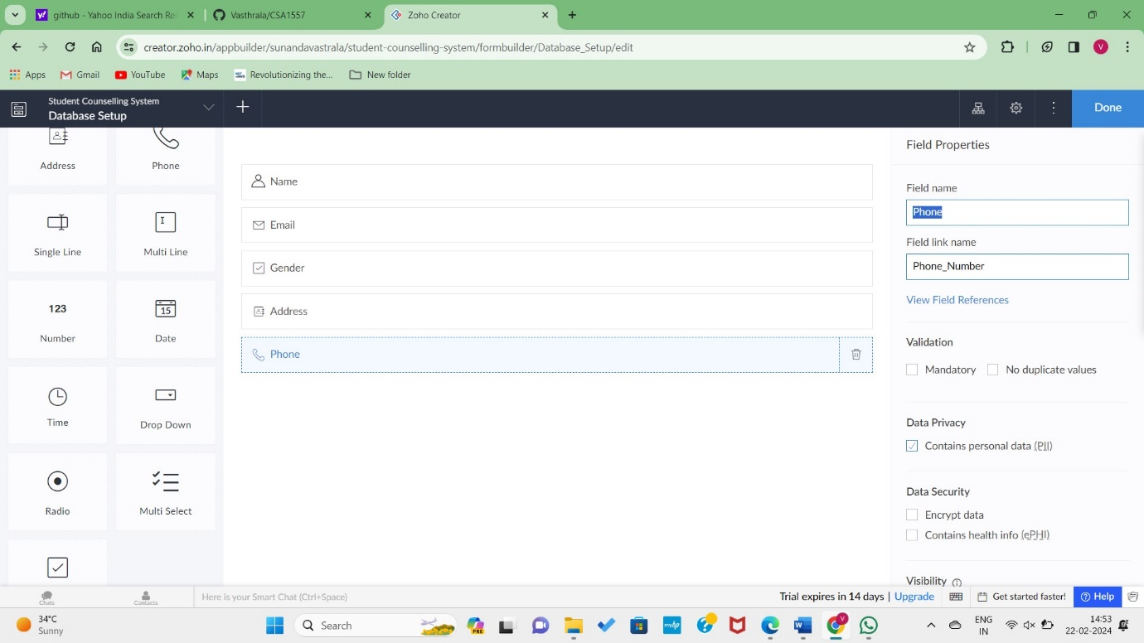

Step2: Data Created using zoho website.



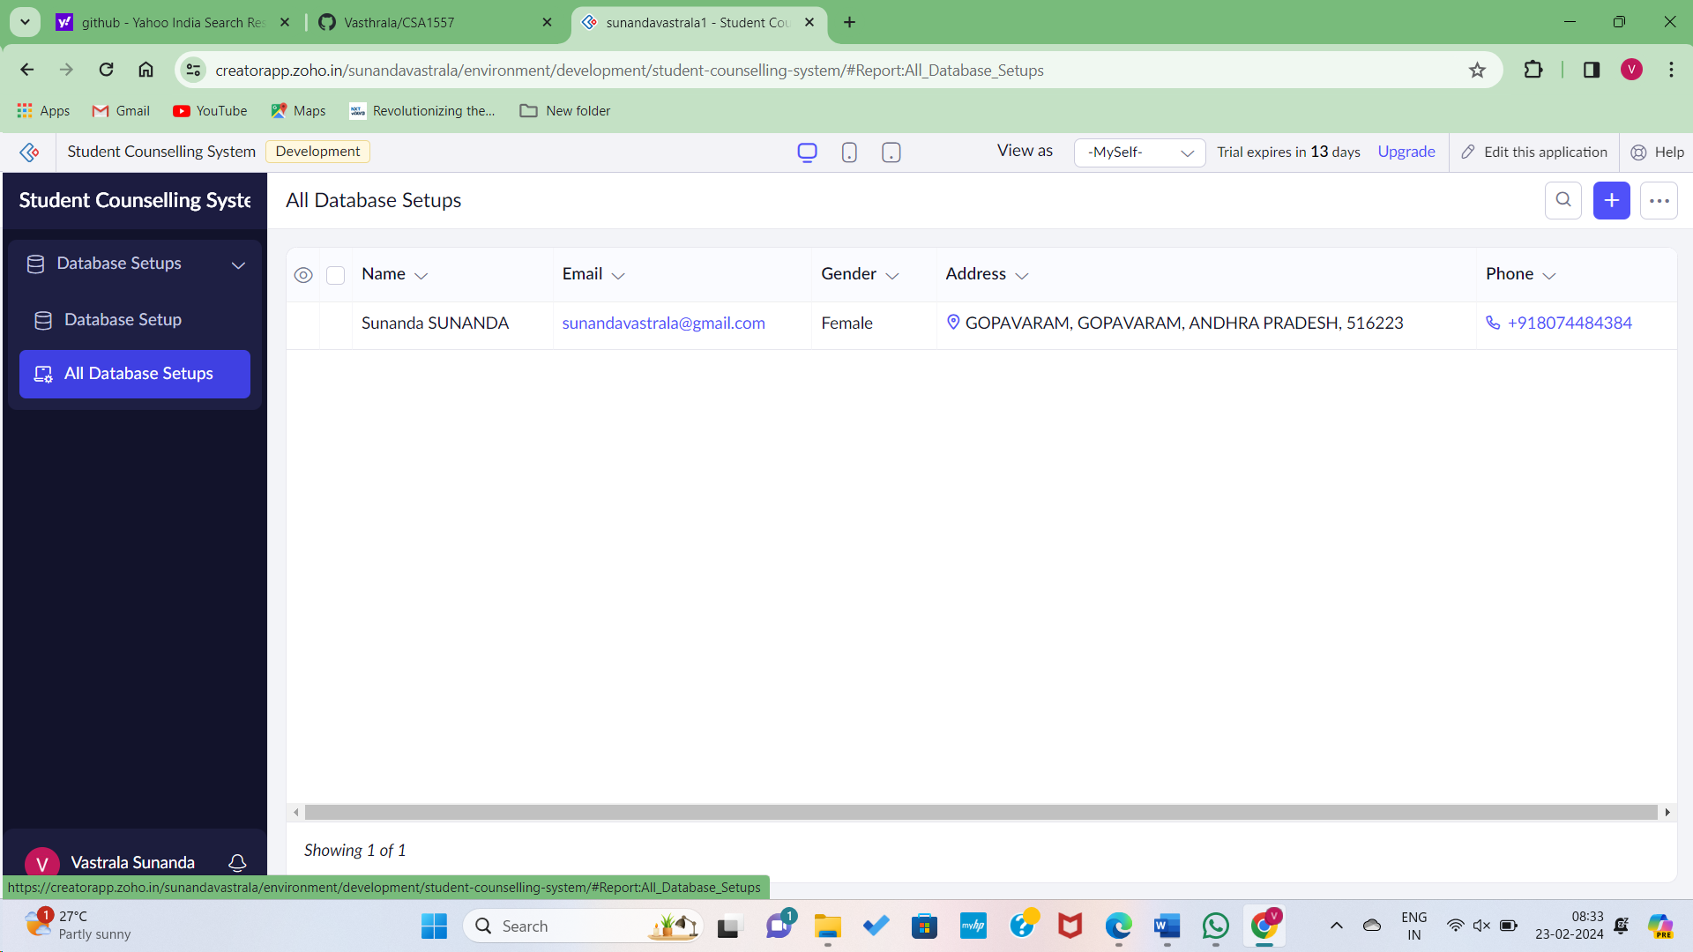

Step3: Implementing a form to add student Academic details.

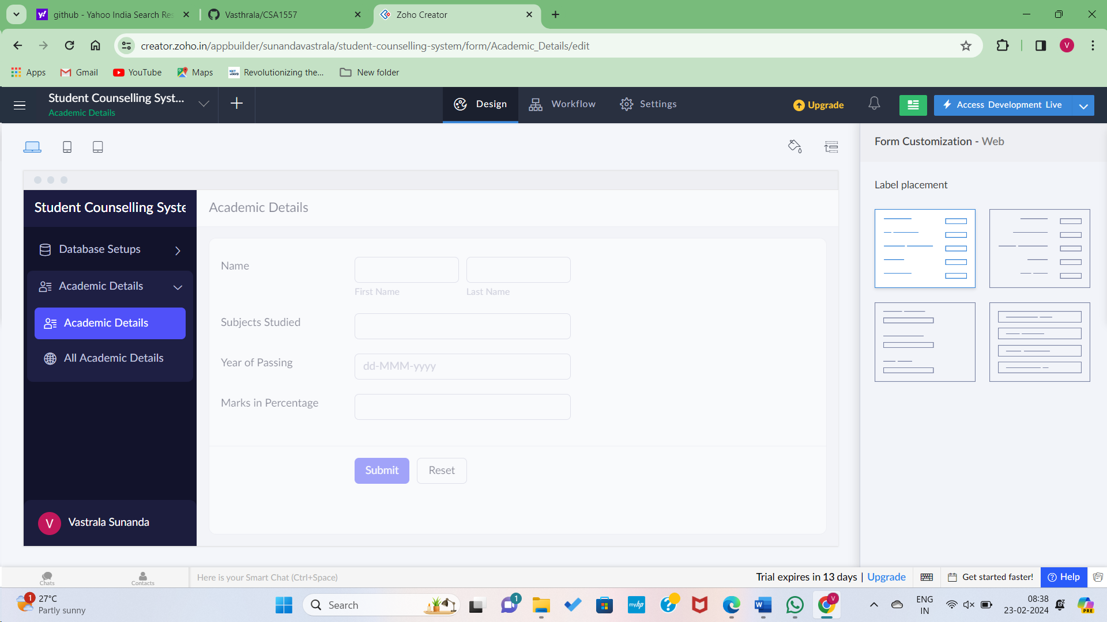

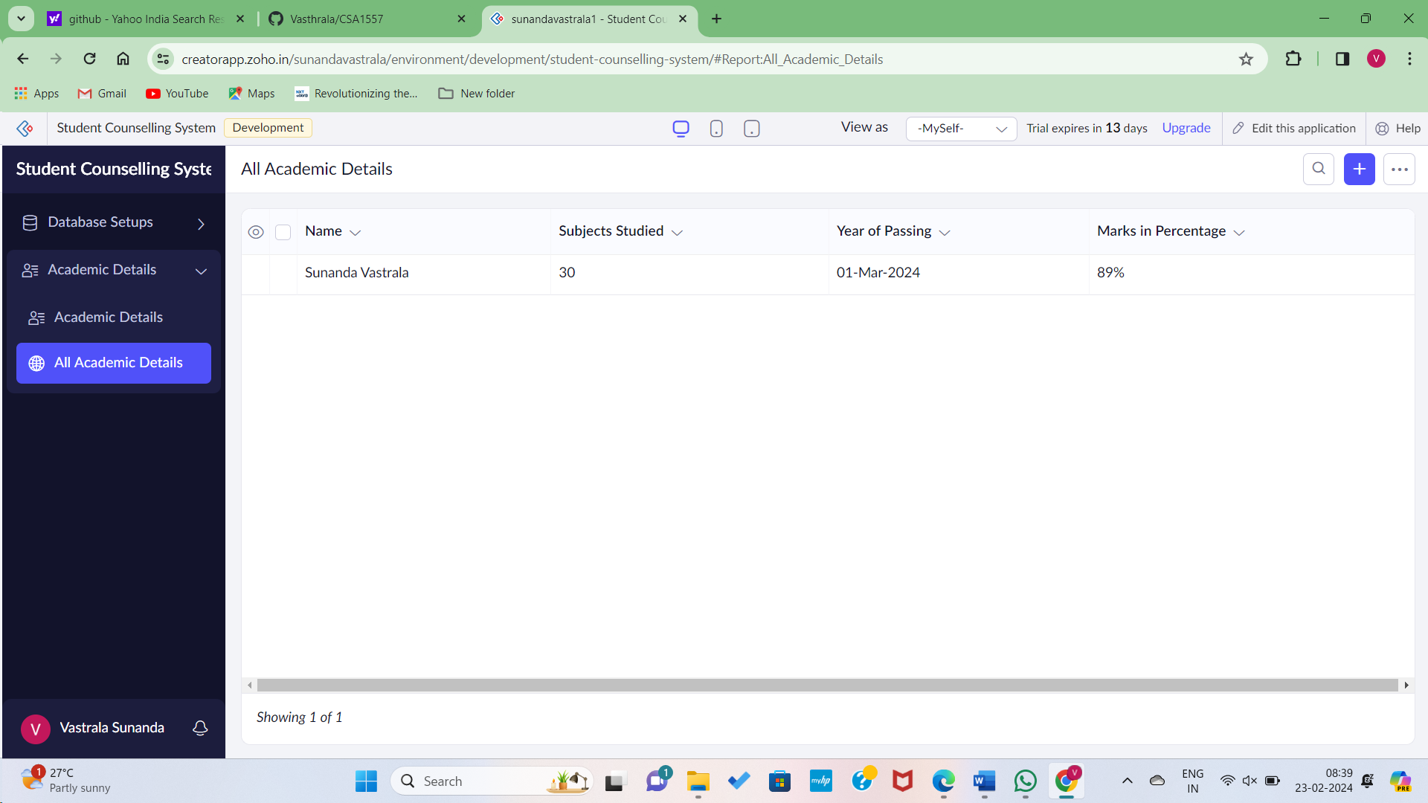

Step4: Implementing features for student counselling system as counselling specifics..

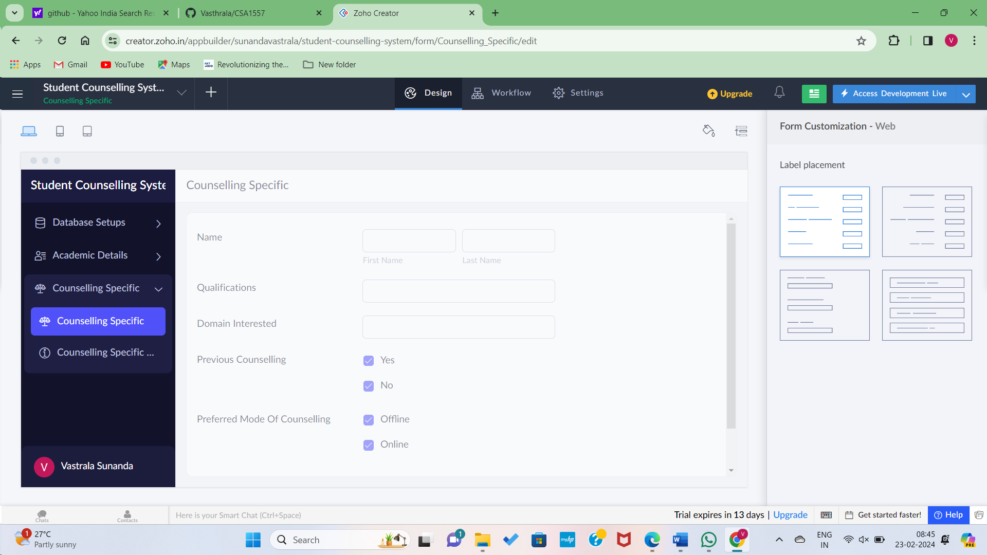

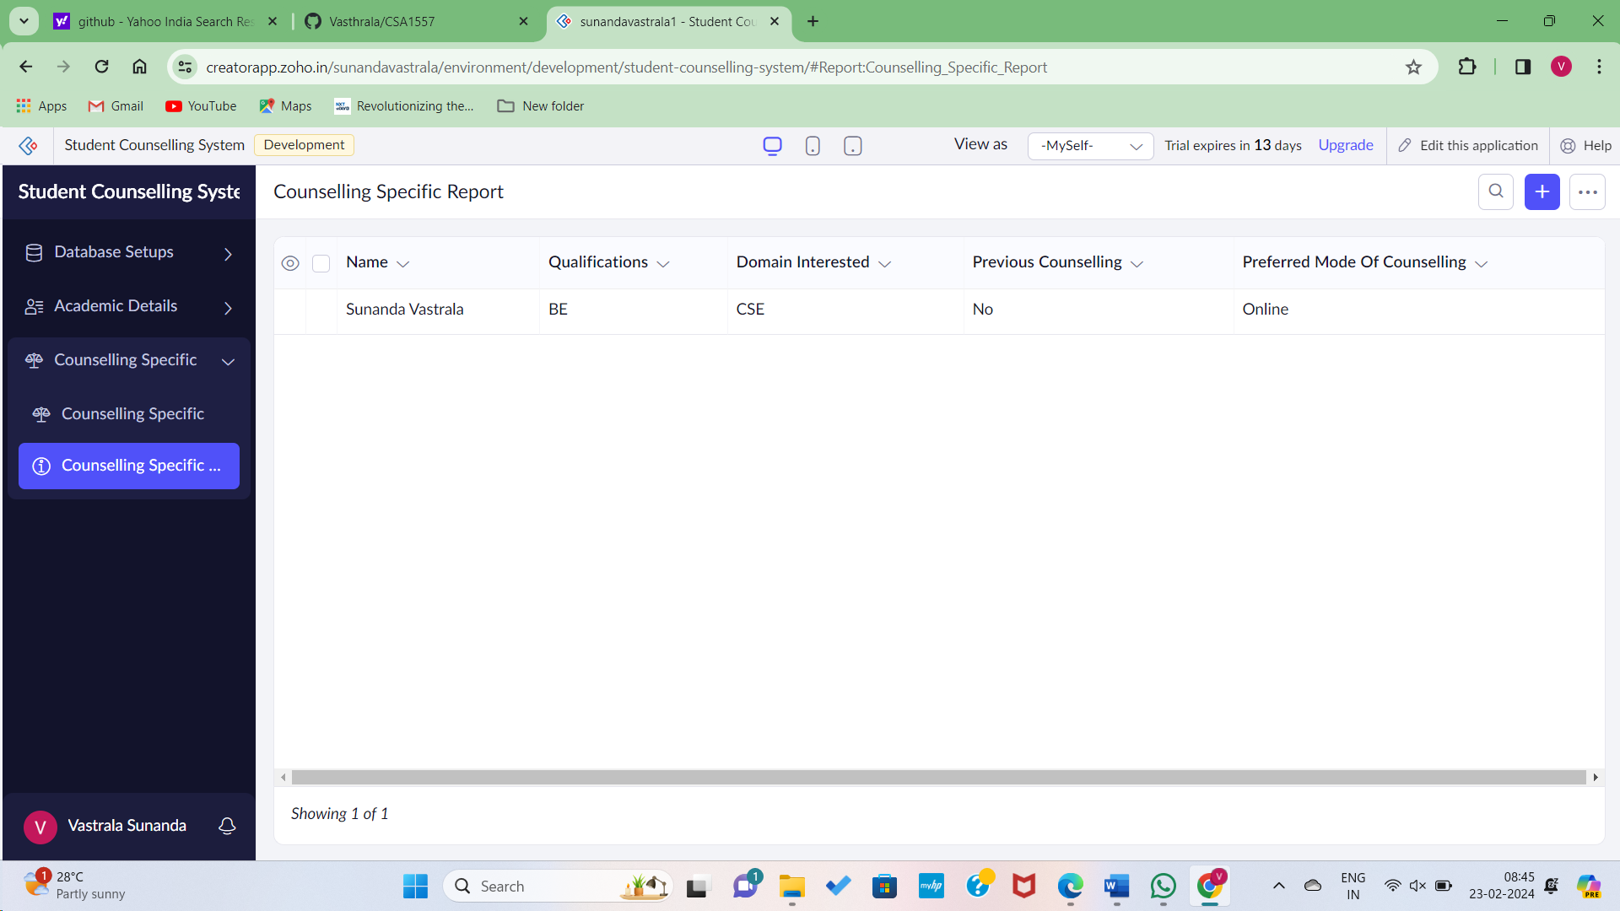

Hence the forms created successfully.